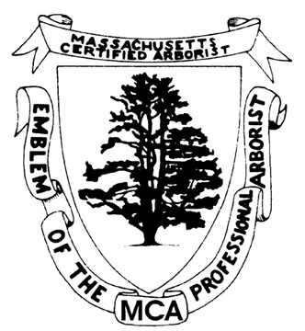
M.C.A. Attendance Form
Sponsoring Organization
Name of Event
Date(s) of Event
Hours of Event
Location of Event
Instructor(s)
Credits Received:

Name Signature MCA Number

Signature of Authorized Sponsor or Instructor: __________________________________________
Print Sponsor or Instructor Name: _________________________________ Date: _____________

Event Sponsor: Make a copy for your file. Sign-in sheets are not to be made available until after the final speaker of the program is finished. Return to: MAA, 67 West Street, Medfield MA 02052 or send electronically to Info@MassArbor.org and title email “CEU SIGN IN SHEET”

